Committee Meeting

Agenda

25th September 2018 at 7:30pm
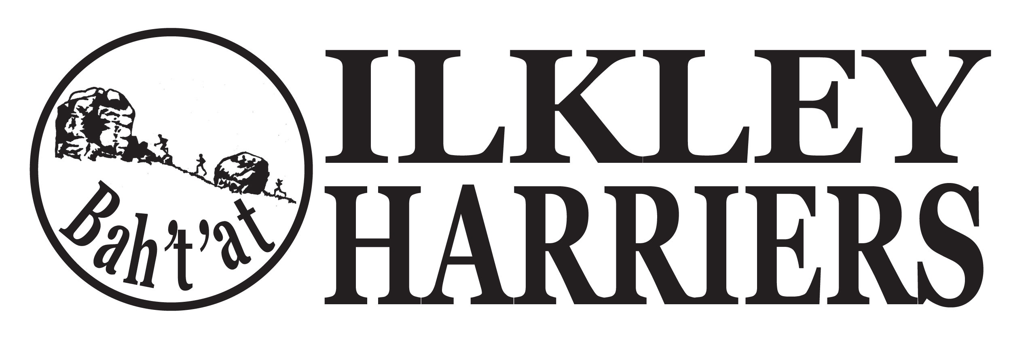
- Apologies

2. Minutes of Meeting 21st August 2018

3. Matters arising

4. Running the Club:

4.1 Nominations for “Outstanding Achievements” of the month for August.

4.2 Northern Athletics: Background re discussions with EA, NA and West Yorkshire Athletics.
Decision required re affiliation (implication is the cost of £2 per member).

4.3 Events: Incline review, (fell) social, IMFR 2019, League update.

4.4 Training sessions: update

4.5 Membership update and readiness for renewals in October.

4.6 Juniors

5. Developing the Club

5.1 (Development plan - after AGM)

5.2 Junior facilities update.

6. AOB

Next meeting: Suggest 6th November for end of year socials preparation, reviews of potential awards winners, races for 2019.

AGM at 8:30

